The Analysis of Non-Time Stamped Videos and the
Introduction of a new Analysis Spreadsheet
by Brad Timerson, Tony George, and Ted Blank
March, 2013 – Updated March, 2017

Introduction

Most models of the Canon ZR camcorders commonly used as occultation recorders contain an internal clock. As long as the small CR-1616 camcorder clock battery is in place and with proper charge, the camera will place an internal (hidden) clock time stamp in each frame of all videos it records. While this internal clock time stamp is only calculated to the nearest whole second, it can be used where KIWI, IOTA-VTI or other valid GPS time inserter time stamps have been placed on the same video tape before and after the event. This allows the observer to determine event times to millisecond accuracy even from videos taken in multi-station occultation deployments where the recording of the actual event does not have a GPS timestamp on every frame. The benefit is that a single GPS video time inserter can cover multiple mobile stations.

This technique makes the reasonable assumption that the drift of the ZR internal clock is constant over the interval of the event. However to minimize error it is recommended that the camera temperature be allowed to stabilize at the outdoor temperature expected for the event before recording the pre-event GPS timestamp, and that the pre- and post-event GPS timestamps be recorded as close to the event time as possible.

This paper describes the procedures to be used in this analysis and introduces a new spreadsheet that completes all the needed calculations to derive event Disappearance and Reappearance times using the internal ZR camcorder clock timestamp on the tape and some GPS timestamps recorded before and after the deployment. It is assumed that the user has a working knowledge of uploading videos from their camcorder to the computer or can get videos from other observers through such resources as Google Drive or DropBox. The user should also have a working knowledge of LiMovie, AviSynth, and Occular.

One-time PC or Laptop Preparation

In addition to Limovie, you should download and install (if you haven’t already) AviSynth at http://www.avisynth.org . Get the version of AviSynth appropriate for your computer, 32-bit or 64-bit. As of the date of this paper (March, 2017), the version available is 2.6.0. Install AviSynth in its own folder on your C:\Program Files (x86) folder.

You will also need a plugin for AviSynth called DVInfo, also available from the AviSynth site. Go to: http://www.avisynth.nl/users/warpenterprises/ Scroll down to find DVInfo. Clicking on the link should initiate a download of the zip file. Extract the files in the Zip folder to the Plugin folder of AviSynth.

Preparing for the occultation event

In the field, remember to follow the instructions for your GPS time inserter to validate that it is providing reliable times. This usually involves a confirmation that the unit has been running long enough to download the latest almanac from the GPS satellites. For example, the IOTA-VTI operations manual recommends powering it for at least 15 minutes before it is needed and also insuring that the hourglass signifying an out-of-date almanac is not being displayed. It is always important that these time insertion units be operated in a manner that provides reliable times.

Before Deployment: Record a Pre-Event Timestamp on Each Camcorder

To save time in the field, typically you will record these clips a few hours prior to the event by sequentially attaching the output of your GPS time inserter to the input of each ZR camcorder you plan to deploy and recording the signal for 10-15 seconds. (Rewinding and playing back this short recording is a also good way to confirm that your camcorder is working properly.)

Remote Deployments

The remote deployment procedure is the same as it would be for a pre-pointed fixed site, except that you will not have a GPS VTI device at each location. Your video camera output will go directly into the AV input jack of the Canon ZR camcorder.

At Pickup Time: Record a Post-Event Timestamp on Each Camcorder

When you return to pick up the equipment at your remote sites, remember before breaking down a site to temporarily connect your GPS time inserter to your ZR camcorder and record a few seconds of GPS timestamp onto the tape immediately following the just-recorded section of tape which (hopefully) contains your event.

Extracting the Pre-Event, Post-Event and Event Video Clips

Back at home you will look over your recordings and hopefully identify some positive events. Once you have a positive event, you should extract the EVENT video clip. The EVENT video clip is extracted from the longer (~10 minute) recording of the event and should include the event plus about 30 seconds before and after. This will give Occular (or other analysis software) the information needed to find the beginning and end of the event. All videos should be in the AVI video format. (Don’t forget to review your entire event clip to identify any possible satellite occultations of the star that might precede or follow the predicted time of the main event.)

For each positive event, you should also extract Pre-event and Post-event clips by rewinding your ZR camcorder and extracting 5-10 second segments of Pre- and Post-event recordings that you put on the tape. Label the files appropriately as pre-event or post-event.

Processing the GPS-Timestamped Pre- and Post-Event Clips

The PRE- and POST- video clips are processed in similar fashion. To begin, in the folder where you are going to store and process your video files, create (or edit) the text files shown below. Each is an AVS script, simply a text file with the extension “.avs” containing AVS commands.

Now instead of opening the AVI file directly in LiMovie, we tell Limovie to open the AVS text file. Contained in the AVS file is the pointer to the AVI file. LiMovie then reads the AVI video file referenced in the AVS file “ClipMain” statement, while at the same time applying the DVInfo plugin. This makes the normally hidden ZR camcorder timestamp visible.

File Event_Name_PRE.avs: (change the string “PRE_Video.avi” to the name of your pre-event AVI video clip)

LoadPlugin("dvinfo.dll")
LoadPlugin(“DirectShowSource.dll”)
ClipMain = ("PRE_Video.avi")
DirectShowSource(ClipMain , pixel_type="RGB24")
DVInfo(ClipMain, "tc_time", 50, 440, "Gothic", 30, 255*65536+255*256+255, 0*65536+0*256+0 ,"%x")
DVInfo(ClipMain, "rec_time", 250, 440, "Gothic", 30, 255*65536+255*256+255, 0*65536+0*256+0 ,"%X (%a)")

File Event_Name_POST.avs: (change the string “POST_Video.avi” to the name of your post-event AVI video clip)

LoadPlugin("dvinfo.dll")
LoadPlugin(“DirectShowSource.dll”)
ClipMain = ("POST_Video.avi")
DirectShowSource(ClipMain , pixel_type="RGB24")
DVInfo(ClipMain, "tc_time", 50, 440, "Gothic", 30, 255*65536+255*256+255, 0*65536+0*256+0 ,"%x")
DVInfo(ClipMain, "rec_time", 250, 440, "Gothic", 30, 255*65536+255*256+255, 0*65536+0*256+0 ,"%X (%a)")

Place all video files to be analyzed in the same folder that contains the AviSynth script files (.AVS).

First we will look at the analysis of the PRE- video file. This same procedure will be used later for the POST- video file.

Open LiMovie. At the top, select the folder containing the .avs files and your videos. Click “AVI File Open”. Then, from the “Files of Type:” drop-down list, choose .avs files instead of the default of .avi files. Your newly created .avs files should now be listed.

Choose the appropriate PRE-event.avs file and then “Open”. If all is working correctly, your video should open and in addition to the time inserter’s GPS timestamp, the ZR camcorder’s internal time stamp should also be shown along the bottom edge, with the suffix “AM” or “PM” attached. (See image below.)

We need to select a whole-second timestamp from the camcorder to associate with a GPS time from the time inserter. Do this by stepping forward through the video one frame at a time using the +1Fr button in Limovie until the camcorder time (the one labeled either “AM” or “PM”) increments to the next whole second. Any whole second can be used.

Below are two views showing the camcorder time stamp incrementing to the next whole second (from 08:05:51 PM to 08:05:52 PM) after hitting the “1Fr+”. Also notice that the ZR camcorder frame count has advanced from “-17” to “-18”, while the Limovie “Current Frame” counter has advanced from 110 to 111. (These two counters are not correlated, except that they both increment by one for each frame that passes by).

Display before clicking the 1Fr+ button in the last frame of camcorder clock second 08:05:51:

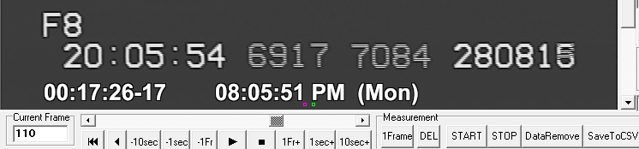

Display after clicking the 1FR+ button, showing camcorder clock second rolling over to 08:05:52:

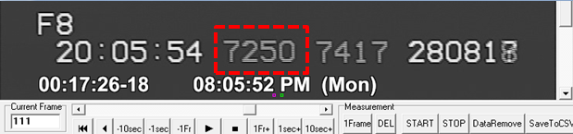

On the screen where the time has just changed to the next whole second, two times need to be recorded from the display. One time is the UT timestamp from the GPS time inserter. In the case of the IOTA VTI as shown in this example, the time to be recorded would be 20:05:54.7250. The decimal portion (.7250, highlighted in red) is used because it is the earlier of the two decimal portions shown and represents the middle of the elapsed time of the frame. Call this recorded VTI time Step 1 for use in the spreadsheet later.

The other time to record is the ZR camcorder time stamp. In this case, one should record 08:05:52 PM. (The AM/PM portion is important.) Call this recorded camcorder time stamp Step 2.

Repeat all these steps with the POST- video. To do this, open in LiMovie the Event_Name_POST.avs script to show this new video. Step through the video using the +1Fr button until the camcorder time stamp (the one labeled AM or PM) rolls to a new whole second. In this example, we selected 04:58:55 AM.

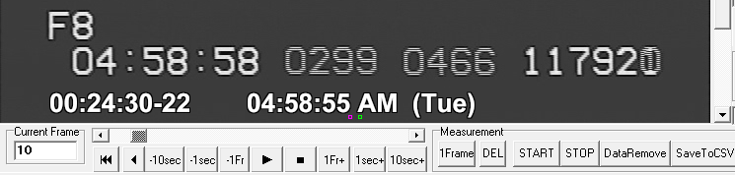

Now record the associated VTI time inserted value of 04:58:58.0299 and call it Step 3. The camcorder clock whole-second time stamp of 04:58:55 AM will be Step 4.

At this point you should have four times recorded:

Step 1 – A GPS timestamp (with milliseconds) from PRE-event video clip
Step 2 – Matching camcorder timestamp (whole second) from PRE-event video clip
Step 3 – A GPS timestamp (with milliseconds) from POST-event video clip
Step 4 – Matching camcorder timestamp (whole second) from POST-event video clip

Processing the Non-Timestamped Event Clip

We move on now to the analysis of the EVENT video clip, which contains the Disappearance and Reappearance events associated with your positive detection. It is assumed at this point that an analysis of this file has been completed using LiMovie (or Tangra) to identify the frames associated with the D and R events. These frames will now be located in Limovie in the time stamped video. Lacking an Occular analysis, record your best estimate of the frame numbers for each of these events. Your reported accuracy may be slightly reduced because you are not measuring fractional frames. Fractional frame times can improve timing accuracy for high (>2.0) SNR light curves.

Create the AVS script below:

Event_Name_EVENT.avs: (change the string “EVENT_Video.avi” to the name of your actual event AVI video clip)

LoadPlugin("dvinfo.dll")
LoadPlugin(“DirectShowSource.dll”)
ClipMain = ("EVENT_Video.avi")
DirectShowSource(ClipMain , pixel_type="RGB24")
DVInfo(ClipMain, "tc_time", 50, 440, "Gothic", 30, 255*65536+255*256+255, 0*65536+0*256+0 ,"%x")
DVInfo(ClipMain, "rec_time", 250, 440, "Gothic", 30, 255*65536+255*256+255, 0*65536+0*256+0 ,"%X (%a)")

Open the Event_Name_EVENT.avs file in LiMovie. This will open the .avi file referenced in the Clipmain statement, with the ZR camcorder timestamp shown at the bottom. Only the camcorder timestamp is visible, because there was no GPS time inserter between the video camera and the ZR camcorder during the event. If you have not already done so, process the video and identify the frames in which the D and R events occur.

Extracting values for the D event (Spreadsheet Step 5 and Step 6)

In this example the D event occurs in the frame with timestamp 04:00:42 with the number -23 visible to the left. Limovie shows this as “Current Frame” 971.

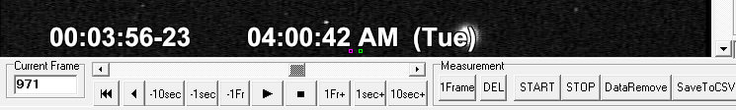

The time stamp at “Current frame” 971, 04:00:42 AM, should be recorded as Step 5, which is the camcorder clock “whole second” associated with the D event.

Now click the -1Fr button repeatedly until the value of 04:00:42 decrements to the next lower second, in this case, 04:00:41. This took us all the way back to Current Frame 950.

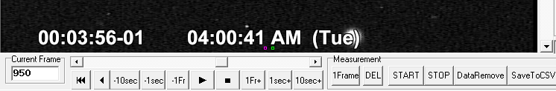

Now click the +1Fr button once to return the camcorder timestamp to 04:00:42:

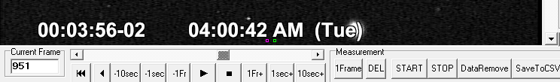

Now we need to determine how many frames into the camcorder clock whole second 04:00:42 the D event occurred. Step forward in the video frame by frame by clicking the +1Fr button, and count how many clicks are required to return the camcorder frame count from “-02” back up to “-23”. In this example it took exactly 20 clicks of the +1Fr button. Record 20 (frames) as Step 6. This will be used by the spreadsheet to compute the additional fraction of a second (20 / 29.97) associated with the D event.

Extracting values for the R event (Step 7 and Step 8)

Now these same steps need to be repeated for the Reappearance or R event. Advance to the frame in which the star reappears. In this example, it is ZR camcorder time 04:00:44 AM with “-26” appearing to the left. Limovie calls this “Current Frame” 1033.

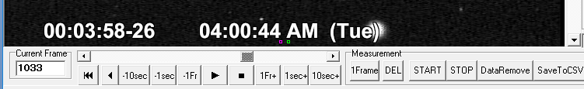

The ZR camcorder time stamp at Limovie “Current Frame” 1033, 04:00:44 AM, should be recorded as Step 7, which is the camcorder clock whole second associated with the R event.

Now click the -1Fr button repeatedly until the value of 04:00:44 decrements to the next lower second, in this case, 04:00:43. This took us all the way back to Limovie “Current Frame” 1008.

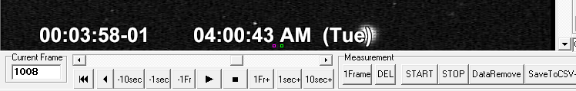

Now click the +1Fr button once to return the camcorder timestamp to 04:00:42. This will advance the camcorder frame count to “-02”:

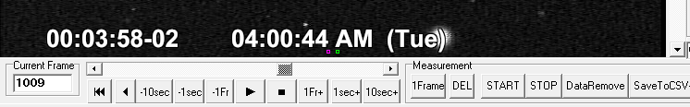

Now we need to determine how many frames into the whole second 04:00:42 the R event occurred. Step forward in the video frame by frame by clicking the +1Fr button, and count how many clicks are required to return the ZR camcorder frame count from “-02” back up to “-26”. In this example it took exactly 24 clicks of the +1Fr button. Record 24 (frames) as Step 8. This will be used by the spreadsheet to compute the additional fraction of a second (24 / 29.97) associated with the R event.

Entering Values Into the Spreadsheet

You are now ready to enter the data you have recorded in the spreadsheet. The spreadsheet takes all 8 input data points, calculates any drift in the camcorder internal clock that may have occurred, calculates the actual event times after applying a correctionfor camcorder clock drift. For this reason, the recording of PRE- and POST- videos should occur as close to the actual recording of the occultation as possible to reduce the amount of drift. It’s also important to record these two videos under similar temperature conditions as will be encountered during the event. All these measures will reduce the amount of drift and increase the accuracy of the event times.

Open the “IOTA Spreadsheet for determining D and R Times from a Non-Time Stamped Canon Camcorder Video” Excel spreadsheet. To create a complete record for yourself or others, fill in the event details at the top of the sheet using the data shown in the template form as an example.

Important first step! Use the “Delete” key to remove any entry that might appear in Step 9, cell B14. This value is needed for the final calculation, but creates a circular reasoning error if it’s in place before starting.

Now, enter the values you have recorded for each of the Steps, 1-8, in the appropriate cell on the spreadsheet. Be especially careful to keep the format correct. Also be sure to include the AM/PM as needed. Note that all UT times (Steps 1 and 3) will always be reported as “AM”.

When you finish, you should note a Recorder Drift value (in parts per million per second) in the green cell, C14. It shouldn’t be too large, most likely less than 100. If it’s larger, look for an error in entering times, especially the AM/PM indication. Now manually type (do not copy/paste) the value shown in the green cell, C14, into Step 9, cell B14, to 3 decimal places. After you’ve done that, the green cell, C14, should now be close to zero and you should see a value in the gray cell, B14, to 2 decimal places.

If you’ve gotten this far and all seems in order, you will now see D and R times as well as a Duration in the darker gray cells along the left edge. These are the times to place on your Report Form.

Congratulations! You have just determined occultation event times from a camcorder video without GPS timestamps using PRE and POST GPS timestamps!

The authors would like to acknowledge Scotty Degenhardt for developing the PRE- POST- GPS time stamping methodology for video analysis. Scotty has pioneered the use of single GPS VTIs for time stamping multiple video recorders for use in mobile site deployments. The methodology used in the “Analyzing a Time Stamped Video” Excel spreadsheet was derived from Scotty’s original Canon ZR Datecode reducer V6.xls spreadsheet.

Other models such as Elura can also be used.
The CR-1616 clock battery is accessed via a small door under the main battery.
Note that the KIWI time inserter requires a powered-up video camera to be attached to its input terminal in order for it to generate an output video signal that will record on your ZR camcorder. The IOTA-VTI will generate its output video signal even without a video camera attached to its input terminal.

