Analysis of Camera Delay Corrections for use in R-OTE and Occular occultation timing extraction programs

**By Tony George**

**November 5, 2014**

Abstract

A study of internal camera delay corrections provided by Gerhard Dangl in his website at [*http://www.dangl.at/ausruest/vid_tim/vid_tim1.htm#methodes*](http://www.dangl.at/ausruest/vid_tim/vid_tim1.htm#methodes) was performed to determine their suitability for use in the occultation timing extraction software programs R-OTE and Occular when processing integrated camera Limovie or Tangra .csv files. The analysis found that the documented diagram delays were useful and resulted in appropriate corrections, but the correction tables did not. The correction table, when used with R-OTE and Occular produced corrections that were in error by approximately one half. This is likely because the tables were produced for correction of manually reduced times where the time is derived from the middle-of-integrated-bin. Both R-OTE and Occular derive times from the start-of-integrated-bin. In addition, correction tables used by John Talbot in the Excel spreadsheet report used in OccultWatcher were derived from the Gerhard Dangl correction tables. The OccultWatcher Excel report spreadsheet corrections and are also in error by approximately one half when used for R-OTE or Occular derived times from integrating camera. A new table of corrections for use with R-OTE and Occular are provided.

The following is a study of camera internal delay correction tables provided by Gerhard Dangl in his website <http://www.dangl.at/ausruest/vid_tim/vid_tim1.htm#methodes> . To study camera delay issues, we need to have a data file that is precisely time stamped with video time inserter (VTI) time stamps that are delayed according to Gerhard Dangl’s measurements, and the data file should also contain an occultation light curve with a known disappearance and reappearance time. Such a data set cannot be achieved from a real world occultation, as the true times of the event are never known. So, for this study, I created a synthetic data .csv file with an exact camera internal time stamp delay as specified in Gerhard Dangl’s camera delay tables superimposed on a known light curve with known disappearance and reappearance times. Once the file is created, it can be analyzed with R-OTE and Occular to see if the corrections shown in Gerhard Dangl’s tables should be applied to get agreement with the times derived from the light curve analysis programs.

The WAT910HX camera was selected for this analysis, as that is the camera I use for most occultations. It has integration capability and requires internal camera delay corrections as per Gerhard Dangl’s analysis. For this study, a camera mode of X64 (64-field integration) was selected for analysis.

The premise of this study is that if Gerhard Dangl’s published corrections work for one camera and operating mode, they should work for all cameras and operating modes. Conversely, if a different correction protocol is required for one camera and operating mode, then a similar correction protocol is required for all cameras and operating modes.

## Camera Delay Analysis Parameters

Here is the camera delay analysis data provided for the WAT910HX at X64 mode of operation.

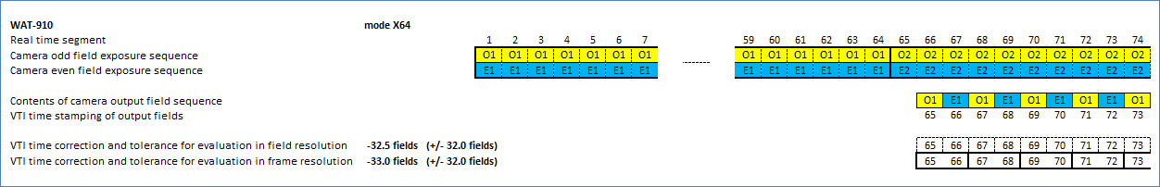

In the above table of camera delay for the WAT910HX the following points apply to the diagram for clarification:

1. The ‘Real time segment’ line is the field number in real time
2. The rows labeled ‘Camera odd field exposure sequence’ and ‘Camera even field exposure sequence’ show what is being recorded inside the camera in real time. Camera fields labeled O1 and E1 contain the same video field exposure image and therefore show the same exposure value for all 64 fields of the integration
3. The line labeled ‘Contents of camera output field sequence’ shows the output of the camera at the field level in real time
4. The line labeled ‘VTI time stamping of output fields’ shows the real time VTI time stamp that is applied to the output field in real time. In this example, the VTI time stamp of output field O1 (exposed at real time segment 1) is stamped with VTI time stamp for field 65 and is output at the real time of field 66.
5. The line labeled ‘VTI time correction … in field resolution’ provides a recommended correction if fields are measured in Limovie and then shows the equivalent real time VTI time stamp on each of the fields output from the camera.
6. The line labeled ‘VTI time correction … in frame resolution’ provides a recommended correction if the frames are measured in Limovie or Tangra, and then shows the equivalent real time VTI time stamp on each of the frames output from the camera.

Based on the above, for this study, a field delay of 64 fields was used to generate the synthetic data file. This is derived from the fact that the O1 field recorded at time t1 in the camera is output with VTI time stamp 65 – a difference of 64 fields.

The synthetic light curve file was generated as follows:

1. A synthetic real time line was created at the field level, starting at time 10.000 seconds and incrementing at the rate of 1.001/60 seconds – the NTSC rate for fields
2. A second time line was created with a 64-field ‘delay’ as documented in Gerhrad Dangl’s anslysis of camera delay for the WAT910HX integrating at mode X64. In this second time line, the first field is labeled with the time stamp 11.0677333 seconds, a time equivalent to a 64-field delay
3. A synthetic occultation light curve was created with the R-OTE sample generator. The occultation was set with real time values as follows:
   1. There were 1955 total readings in the synthetic file
   2. Disappearance = field 950 = 25.832 seconds
   3. Reappearance = field 1250 = 30.838 seconds
   4. D and R fields were arbitrarily selected. The event times were taken directly from the synthetic real time line for the fields selected for D and R
   5. Intensity of star = 500, intensity of asteroid = 1000, baseline noise = 50, and event noise = 50
   6. True SNR = 500/50 = 10, so the event is going to be quite obvious – an effort to test the delay correction rather than inject noise to confuse whether or not the delay correction is working correctly. Other tests could be done with more noise added, however, that is not the focus of this study.
   7. The light curve was generated with a 64-field integration, with readout noise of 15 within each integrated block. This was an arbitrary amount of noise added to the integration blocks to make the light curve look similar to real light curves.
   8. The synthetic light curve appears as follows:

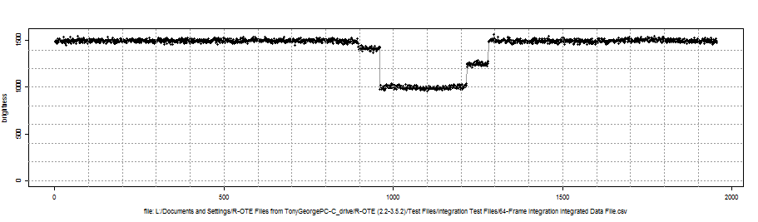

1. The synthetic light curve was concatenated into an R-OTE csv file format, using the 64-field delay time line with the ‘real time’ occultation light curve.
2. The concatenated .csv file was opened in R-OTE and analyzed to derive the D and R times that would be obtained from the synthetic file similar to a real file with 64-field camera delay time stamps.
   1. Time stamps were processed to associate a time stamp with the start of the first field. A timedelta (the duration of each field) was set at 1.001/60 or 0.0166833333 seconds per field.
   2. The time line was checked for data continuity. No time line errors were found, validating that the synthetic file was created correctly.
   3. The file was block integrated by a factor of 64 readings (to agree with apparent 64-integration present in the data file)
   4. The block-integrated light curve appears as follows:

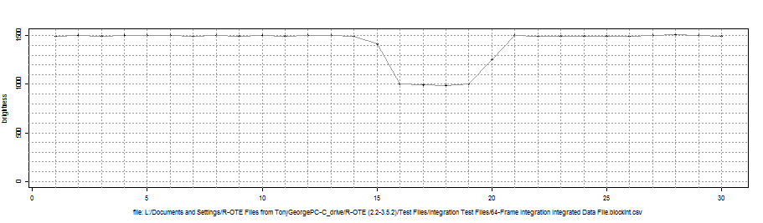

The results of the analysis of the synthetic 64-field block-integrated light curve are discussed in the Results section below.

## VTI Correction

In addition to internal camera delay corrections, there is also a correction that needs to be applied to the VTI time stamp depending on which VTI is used and how the VTI time stamps are recorded by Limovie and/or Tangra. The following diagram from Gerhard Dangl demonstrates this issue. In the top row, a hypothetical time line starting at time t1 shows the exposures of each field O1 and E1 and then in the rows below, the VTI time stamps that are actually applied on the O1 and E1 fields as they come out from the camera.

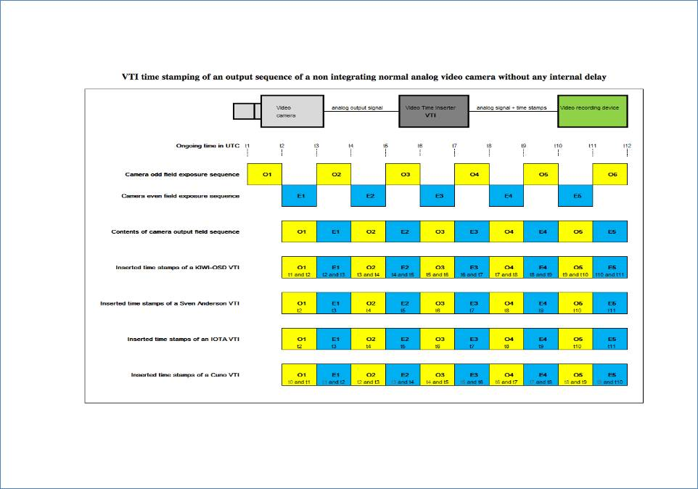

R-OTE requires the t1 time (the start time of each field) be input to the program to get accurate event times for measure disappearance and reappearance of the occultation. Some VTIs output a time that is 1-field late, that is, the t2 time is stamped on the O1 field, instead of the t1 time. The IOTA and Sven Anderson VTIs are examples of this. The KIWI VTI stamps the O1 field with t1 and t2 times, however, both Limovie and Tangra record the t2 time in the .csv file output, so a delay is also necessary for a KIWI VTI. As a consequence, .csv files recorded with these VTIs and reduced with R-OTE require a 1-field correction be applied. This correction will not be applied to this study, however, as no VTI delay in the time stamp is assumed in the synthetic data set.

Occular requires the t2 time be input to the program to get accurate event times. For most .csv files, no VTI delay correction need be applied to Occular derived times.

## Results

Below is the table of results. The ‘true time’ of the occultation disappearance and reappearance is shown in Column 2. The uncorrected measured disappearance and reappearance times for R-OTE and Occular are shown in Columns 3 and 4. The field correction to the measured times recommended by Gerhard Dangl are shown in Column 5. The measured times were corrected using various options including Gerhard’s recommended correction, Gerhard’s recommended correction X 2, and a 64-field correction indicated by Gerhard’s camera delay diagram. The corrected times are shown in Columns 6 – 9. The difference between the true time and the corrected measured time are shown in Columns 10 – 13. The results show that for R-OTE and Occular analysis of integrated camera results, Gerhard Dangl’s recommended corrections are off by at least ½ of the full correction needed – approximately 0.508 seconds. When a 2x Gerhard’s correction is applied to R-OTE results, the difference is negative – approximately 0.014 – 0.036. If a 64 field correction is applied to R-OTE results, the difference is less than for either of the Gerhard Dangl correction options, and closer to the true value. If a 64-field correction is applied to Occular results, the difference in comparable to but slightly greater than the 2X Gerhard Dangl correction. Here is the table of results:

|  |  |  |  |  |  |  |  |  |  |  |  |  |
| --- | --- | --- | --- | --- | --- | --- | --- | --- | --- | --- | --- | --- |
| **Column 1** | **Column 2** | **Column3** | **Column 4** | **Column 5** | **Column 6 – 9** | | | | **Column 10 – 13** | | | |
| **Event** | **Simulated Disappearance True Time**  **(seconds)** | **R-OTE Measured Disappearance (Uncorrected) Time** | **Occular Measured Disappearance (Uncorrected) Time** | **Field Correction recommended by Gerhard Dangl**  **(fields)** | **Corrected Disappearance Time Analysis**  **(seconds)** | | | | **Difference between corrected times and True Time (seconds)** | | | |
| R-OTE Correct by Gerhard Dangl correction | R-OTE Correct by 2X Gerhard Dangl correction | R-OTE Correct by 64 fields | Occular Correct by 64 fields | R-OTE Correct by Gerhard Dangl correction | R-OTE Correct by 2X Gerhard Dangl corretion | R-OTE Correct by 64 fields | Occular Correct by 64 fields |
| Disapperance | 25.832 | 00:26.902 | 00:26.932 | -32.5 | 26.340 | 25.818 | 25.834 | 25.846 | 0.508 | -0.014 | 0.002 | 0.014 |
| Reappearance | 30.838 | 00:31.886 | 00:31.993 | -32.5 | 31.344 | 30.802 | 30.818 | 30.925 | 0.506 | -0.036 | -0.020 | 0.087 |

## Conclusions

Gerhard’s correction tables are off by at least ½ of the full correction needed for analyses done with R-OTE or Occular. If VTI delays are considered as a separate correction, then a delay of 64-fields is observed to be the correction that produces results closest to the true time in R-OTE and Occular.

This study has provided a better understanding of how the Gerhard Dangl camera delay corrections need to be applied for R-OTE and Occular measured results. With this understanding, I have created a full table of corrections by Camera and integration setting (if applicable) appended to the end of this paper. These corrections should be applied to all R-OTE and Occular measured times produced from integrating video cameras on all future reports provided to IOTA.

## Recommendations

The correction tables provided in this paper should be used by Bob Anderson to create either an automatic correction in R-OTE, or, a pop up table of corrections that the user can apply. If corrections can be applied prior to submission of results to regional coordinators, it will greatly simplify the data gathering and reporting process.

Similarly, the correction tables provided in this paper should be used by John Talbot to provide a separate correction option in the OccultWatcher Excel spreadsheet if R-OTE or Occular are used in the data reduction and corrections are not already applied to the results by the program.

Neither the correction tables in Gerhard Dangl’s website, nor the current corrections provided in the OccultWatcher Excel spreadsheet report should be used with R-OTE or Occular derived times when processing integrated camera Limovie or Tangra .csv files.

The following table of corrections should be used for integrating camera delay corrections when analyzing light curves with R-OTE and Occular occultation timing extraction programs:

|  |  |  |  |  |
| --- | --- | --- | --- | --- |
| R-OTE/Occular Camera Delay Correction Tables | | | | |
|  |  |  |  |  |
| WAT-120N   (CCIR); WAT-120N+ (CCIR); WAT-120N (EIA); and, WAT-120N+ (EIA) | | | | |
|  |  |  |  |  |
| Mode | | Field Delay | Time Correction | |
|  |  |
| WAT-120N | WAT-120N+ |  | CCIR | EIA |
| Off | High 1-5 | 2 | -0.0400 | -0.0334 |
| Frame 1 | Slow 1 | 3 | -0.0600 | -0.0501 |
| Frame 2 | Slow 2 | 5 | -0.1000 | -0.0834 |
| Frame 4 | Slow 3 | 9 | -0.1800 | -0.1502 |
| Frame 8 | Slow 4 | 17 | -0.3400 | -0.2836 |
| Frame 16 | Slow 5 | 33 | -0.6600 | -0.5506 |
| Frame 32 | Slow 6 | 65 | -1.3000 | -1.0844 |
| Frame 64 | Slow 7 | 129 | -2.5800 | -2.1522 |
| Frame 128 | Slow 8 | 257 | -5.1400 | -4.2876 |
| Frame 256 | Slow 9 | 513 | -10.2600 | -8.5586 |
|  |  |  |  |  |
| WAT-910HX and WAT-910BD   (CCIR) and WAT-910HX and WAT-910BD (EIA) | | | | |
|  |  |  |  |  |
| Mode | | Field Delay | Time Correction | |
| WAT-910HX |  |
| WAT-910BD |  |  | CCIR | EIA |
| No-integ -- 1/60 or 1/50 |  | 1 | -0.0200 | -0.0167 |
| 2X |  | 2 | -0.0400 | -0.0334 |
| 4X |  | 4 | -0.0800 | -0.0667 |
| 8X |  | 8 | -0.1600 | -0.1335 |
| 16X |  | 16 | -0.3200 | -0.2669 |
| 32X |  | 32 | -0.6400 | -0.5339 |
| 64X |  | 64 | -1.2800 | -1.0677 |
| 128X |  | 128 | -2.5600 | -2.1355 |
| 256X |  | 254 | -5.0800 | -4.2376 |

|  |  |  |  |  |
| --- | --- | --- | --- | --- |
|  |  |  |  |  |
| Mintron 12V1C-EX   (CCIR) and Mintron 12V1C-EX (EIA) | | | | |
|  |  |  |  |  |
| Mode | | Field Delay | Time Correction | |
|  |  |
|  |  |  | CCIR | EIA |
| Off |  | 0 | 0.0000 | 0.0000 |
| 2X |  | 1 | -0.0200 | -0.0167 |
| 4X |  | 3 | -0.0600 | -0.0501 |
| 6X |  | 5 | -0.1000 | -0.0834 |
| 8X |  | 7 | -0.1400 | -0.1168 |
| 12X |  | 9 | -0.1800 | -0.1502 |
| 16X |  | 15 | -0.3000 | -0.2503 |
| 24X |  | 23 | -0.4600 | -0.3837 |
| 32X |  | 31 | -0.6200 | -0.5172 |
| 48X |  | 47 | -0.9400 | -0.7841 |
| 64X |  | 63 | -1.2600 | -1.0511 |
| 96X |  | 93 | -1.8600 | -1.5516 |
| 128X |  | 127 | -2.5400 | -2.1188 |
|  |  |  |  |  |
| PC165DNR   (EIA) | |  |  |  |
|  |  |  |  |  |
| Mode | | Field Delay | Time Correction | |
|  |  |
| PC165DNR   (EIA) |  |  | CCIR | EIA |
| No-integ |  | 1 |  | -0.0167 |
| 2X |  | 2 |  | -0.0334 |
| 4X |  | 4 |  | -0.0667 |
| 8X |  | 8 |  | -0.1335 |
| 16X |  | 16 |  | -0.2669 |
| 32X |  | 32 |  | -0.5339 |
| 64X |  | 64 |  | -1.0677 |
| 132X |  | 128 |  | -2.1355 |
| 256X |  | 256 |  | -4.2709 |

|  |  |  |  |  |
| --- | --- | --- | --- | --- |
| SCB-2000N   (EIA) | |  |  |  |
|  |  |  |  |  |
| Mode | | Field Delay | Time Correction | |
|  |  |
| SCB-2000N   (EIA) |  |  | CCIR | EIA |
| No-integ |  | 2 |  | -0.0334 |
| 2X |  | 3 |  | -0.0501 |
| 4X |  | 5 |  | -0.0834 |
| 6X |  | 7 |  | -0.1168 |
| 8X |  | 9 |  | -0.1502 |
| 10X |  | 11 |  | -0.1835 |
| 12X |  | 13 |  | -0.2169 |
| 14X |  | 15 |  | -0.2503 |
| 16X |  | 17 |  | -0.2836 |
| 24X |  | 25 |  | -0.4171 |
| 32X |  | 33 |  | -0.5506 |
| 64X |  | 65 |  | -1.0844 |
| 128X |  | 129 |  | -2.1522 |
| 256X |  | 257 |  | -4.2876 |
| 512X |  | 513 |  | -8.5586 |
|  |  |  |  |  |
| Mallincam MCH Plus Color   (CCIR) and Mallincam MCH Plus Color (EIA) | | | | |
|  |  |  |  |  |
| Mode | | Field Delay | Time Correction | |
|  |  |
| Mallincam MCH Plus Color |  |  | CCIR | EIA |
| Off |  | 1 | -0.0200 | -0.0167 |
| sense up X2 |  | 2 | -0.0400 | -0.0334 |
| sense up X4 |  | 4 | -0.0800 | -0.0667 |
| sense up X6 |  | 6 | -0.1200 | -0.1001 |
| sense up X8 |  | 8 | -0.1600 | -0.1335 |
| sense up X12 |  | 10 | -0.2000 | -0.1668 |
| sense up X16 |  | 16 | -0.3200 | -0.2669 |
| sense up X24 |  | 24 | -0.4800 | -0.4004 |
| sense up X32 |  | 32 | -0.6400 | -0.5339 |
| sense up X48 |  | 48 | -0.9600 | -0.8008 |
| sense up X64 |  | 64 | -1.2800 | -1.0677 |
| sense up X96 |  | 94 | -1.8800 | -1.5682 |
| sense up X128 |  | 128 | -2.5600 | -2.1355 |
|  |  |  |  |  |
| PC164C-EX2 (EIA); SK-1004XC (CCIR); WAT-902H2 Ultimate   (CCIR); and WAT-902H2 Ultimate (EIA) | | | | |
|  |  |  |  |  |
| Mode | | Field Delay | Time Correction | |
|  |  |
|  |  |  | CCIR | EIA |
| no-integ |  | 0 | 0.0000 | 0.0000 |

NOTE:

|  |  |  |  |  |
| --- | --- | --- | --- | --- |
| 6X |  | 5 | -0.1000 | -0.0834 |

**Red marked modes should not be used for astronomical recordings with the purpose for time or magnitude measurements. Integration time and exposure time can be different from the nominal values shown in the tables. Integrated segments contain frames with no photometric data and can result in erroneous time or magnitude measurements.**

## Acknowledgments

I would like to acknowledge Bob Anderson, who created the synthetic light curve generation software used in this study, as well as the two programs evaluated – R-OTE and Occular. I would also like to acknowledge Gerhard Dangl who produced all the camera delay data used in this study and graciously responded to several clarification questions. Brad Timerson provided helpful editing comments. Thank you all.